SKILL – 1
Captured TCP Packets in Wireshark

Captured UDP Packets in Wireshark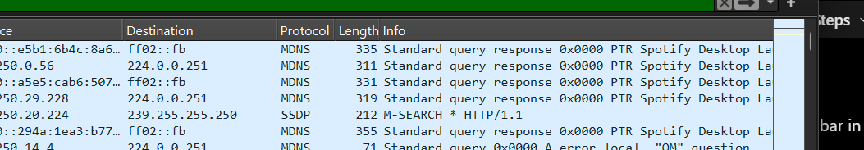

Selection of UDP Packet for Header Analysis
Frame Details and Frame Length Analysis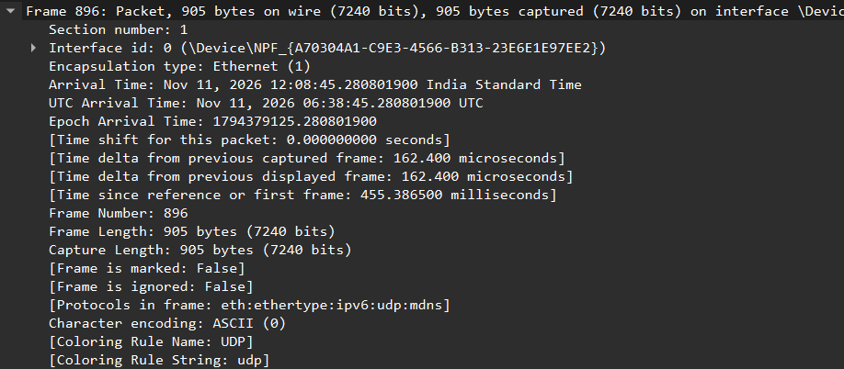

Ethernet II Header Details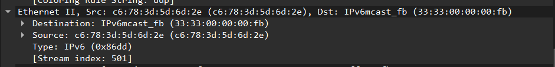

IPv6 Header Information and Payload Length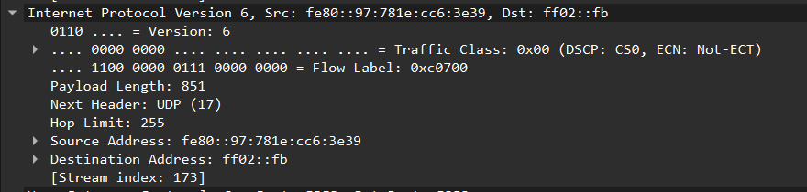
UDP Header Details and Length Analysis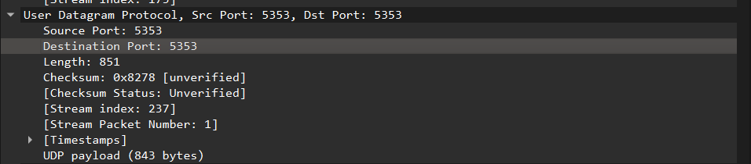

Multicast DNS (mDNS) Packet Details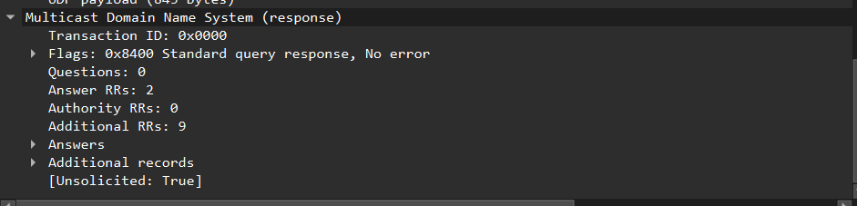

Wireshark Capture File Properties and Statistics

